Module 4 Critical Thinking Assignment: Looping with Floating Points Option 1

Grant Brosovich

CSU-Global

CSC320-01

Dr. Terrell Brandes

April 12, 2025

**Pseudocode:**

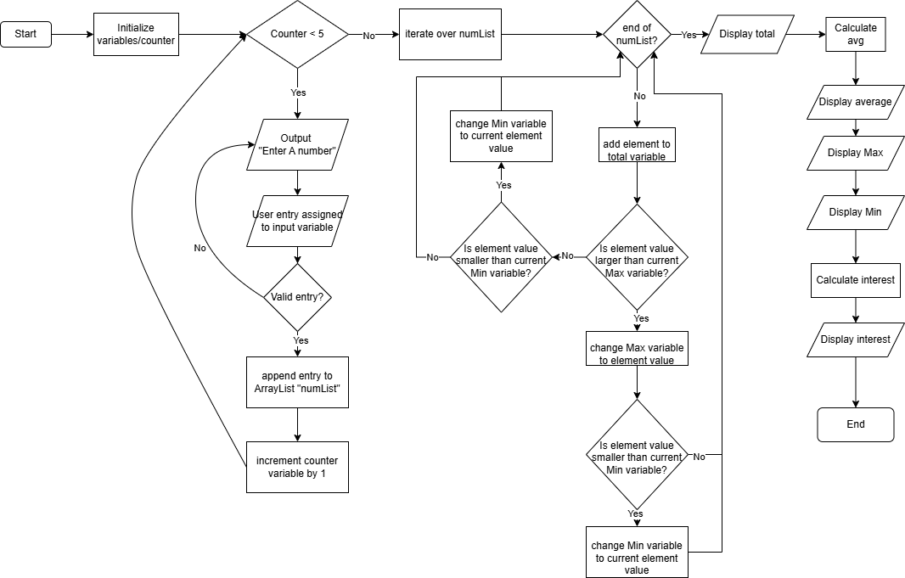

**Source code:**

**import** java.util.Scanner;

**import** java.util.ArrayList;

**public** **class** Module4 {

**public** **static** **void** main(String[] args) {

**double** total = 0.0;

**double** avg = 0.0;

**double** max = 0;

**double** min;

**double** rate = .20;

**double** interest = 0.0;

**int** counter = 0;

Scanner sc = **new** Scanner(System.***in***);

ArrayList<Double> numList = **new** ArrayList<Double>();

**while** (counter < 5) {

System.***out***.println("Please enter a number");

String input = sc.nextLine();

**try** {

**double** num = Double.*parseDouble*(input);

numList.add(num);

} **catch** (NumberFormatException e) {

System.***out***.println("That was not a valid entry.");

}

counter += 1;

}

sc.close();

min = numList.get(0);

**for** (**int** x = 0 ; x < numList.size(); x ++) {

total += numList.get(x);

**if** (numList.get(x) > max) {

max = numList.get(x);

}

**if** (numList.get(x) < min) {

min = numList.get(x);

}

}

System.***out***.println("The total is " + total);

avg = total / numList.size();

System.***out***.println("The average is " + avg);

System.***out***.println("The maximum is " + max);

System.***out***.println("The minimum is " + min);

interest = total * rate;

System.***out***.println("The interest is " + interest);

}

}

**Running application screenshots:**

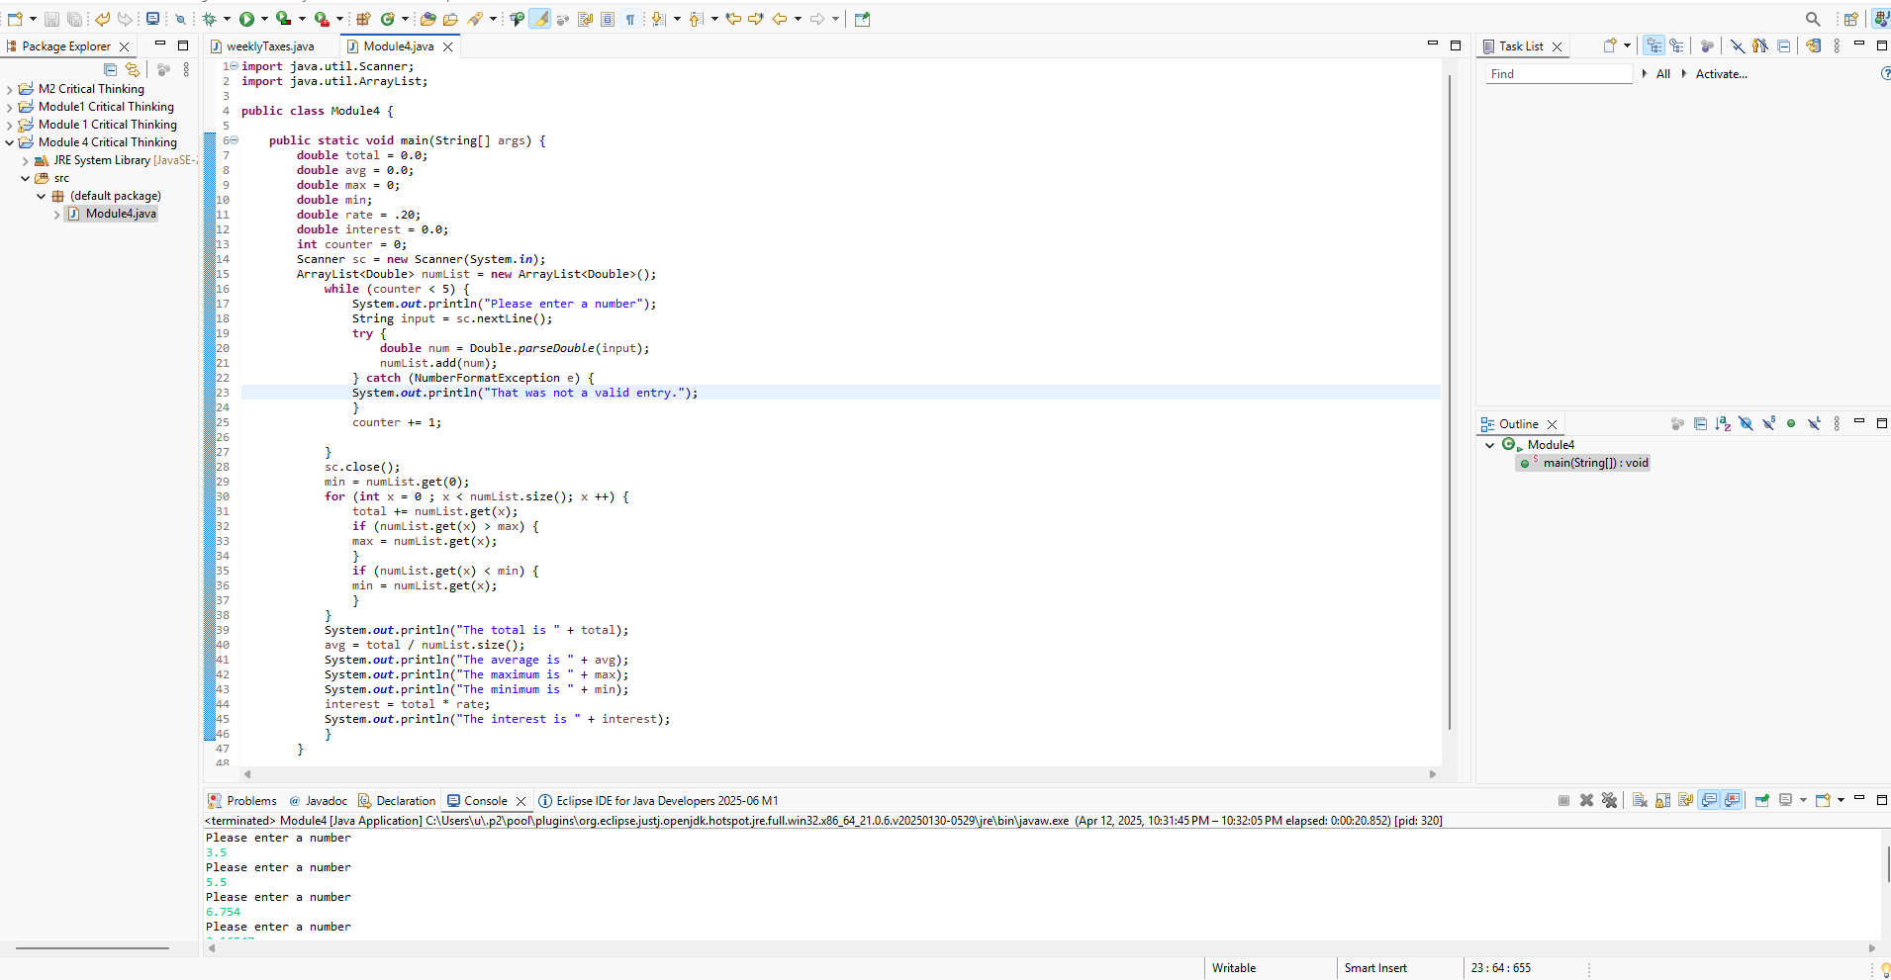

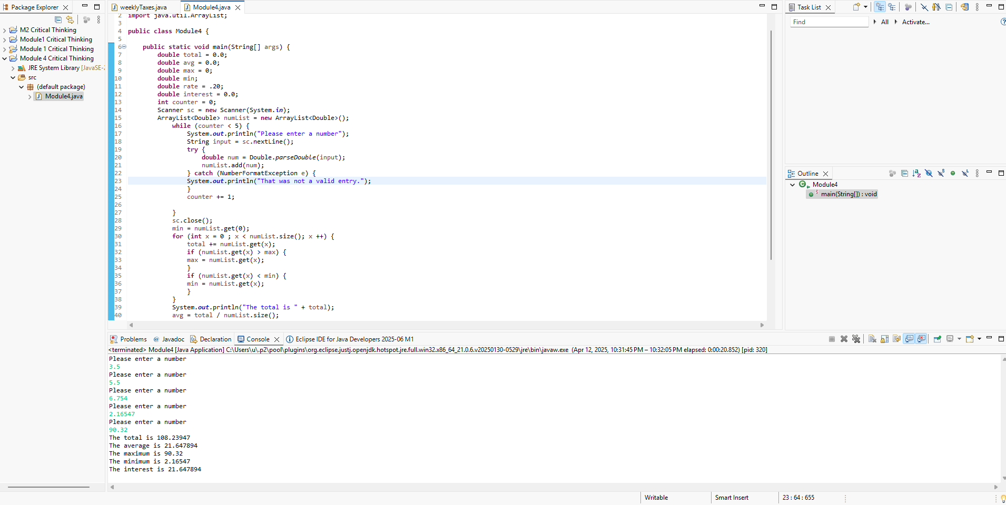

**Link to GitHub repository for Module 4 Critical Thinking Assignment:**

<https://github.com/GrantBros/Module4.git>

All the files are located in the Module4 folder of the Github repository in their original format.